**PROJECT REPORT**

(PROJECT SEMESTER TRAINING)

## PANCHKULA AT YOUR FINGERTIPS

Submitted by

**(Sonal Bansal)**

**101303069**

Under the Guidance of

**Mrs. Rimpy Sharma**

Trainer,Core Java

Vashisht Computer Centre,Panchkula

# Department of Computer Science and Engineering

**THAPAR UNIVERSITY, PATIALA**

**August 2015**

# DECLARATION

I hereby declare that the project work entitled (“Panchkula At Your FingerTips”) is an authentic record of our own work carried out at Vashisht Computer Centre ,Sector 15,Panchkula as requirements of 6 weeks summer training for the award of degree of B.E. (Computer Science & Engineering), Thapar University, Patiala, under the guidance of Mrs. Rimpy Sharma(Trainer,Core java) , during 1 June to 20 July, 2014.

We further declare that no part of this report is copied from Internet or any other source.

Jatin Mehta

101303069

Date: ___________________

**ACKNOWLEDGEMENT**

I am indebted to **Mrs. Rimpy Sharma**, **Vashisht Computer** **Institute**, Sector 15, Panchkula for providing academic inputs, guidance & encouragement throughout the training period.

Many thanks to my team member, Aarzoo bhatia and my colleagues who have helped me develop the project !

I express my sincere thanks to the Department of Computer Science and Engineering for giving me an opportunity to work on the project. I am also grateful to my parents for supporting me in this venture of ours.

Jatin Mehta

**ABSTRACT**

The PANCHKULA AT YOUR FINGERTIPS application is aimed to provide detailed information(locations) to the users on various categories and take their reviews. The application provides local information about the city of Panchkula which includes hotels, colleges, eating joints, showrooms, hospitals etc.

**Front end** would be JavaSE and the **Back end** will be MySQL database.

It is user friendly as the user just have to select the category about which he wants the information and the details get displayed.We have also added a blog section where users can easily share their queries about panchkula and add to their knowledge.The administrator can also easily add more details in the database with the help of the administrator login option.

The project aims at reducing the hardships of those residing in Panchkula but facing the problems of finding the information about their city. The application can easily be installed on your laptop or computer and can then be run anywhere and the Best information gets displayed.

|  |  |  |
| --- | --- | --- |
| **S.No** | **CONTENTS** | **PAGENO** |
| 1 | Company Profile |  |
| 2 | Introduction |  |
| 2.1 | Scope |  |
| 3 | Background |  |
| 3.1 | Feasibility Analysis |  |
| 3.2 | Requirement Analysis |  |
| 3.3 | Ishikawa Diagram |  |
| * 4 | Design |  |
| 4.1 | Functionalities |  |
| 4.2 | Data Flow Diagram |  |
| 4.3 | Use Case Diagram |  |
| 5 | Implementation |  |
| 5.1 | Detailed Analysis |  |
| 5.1.1 | User Module |  |
| 5.1.2 | Blog Section |  |
| 6 | Optimisation |  |
| 7 | Experimentation |  |
| 8 | Evaluation |  |
| 9 | Limitations |  |
| 10 | Conclusion and Future work |  |
| 11 | Bibliography |  |

**COMPANY PROFILE**

**VASHISHT COMPUTER INSTITUTE** is an ISO 9001-2008 certified institute which specializes in Computer Software Training, Software Development, Software Consulting and Corporate Training.

In today’s computing era, computerization has become an essential requirement for every organization to maintain the quantitative pace of organization .To overcome the pitfalls of manual systems it is advisable to prefer automatic mode of activities by the organization.

In the consideration of the above major points, we at Vashisht are into the corporate training of well customized software, which gives cent percent satisfaction to the students and improves their standards and technical skills.

With our expertise we make students not only understand but anticipate industry’s needs and get services and information to them in the need based time in the most effective way possible.

**Quality Administration Team**

The QA team is engaged in handling the entire training activities of the organization. The team is regularly updated about the latest developments in the fast changing IT industry and need based training is provided on regular intervals. The team is also capable to meet challenging projects in various IT fields.

We strongly believe that top-notch talent only can help to achieve the task & aid our students/clients transform their business in the world where geographical boundaries are fast dissolving.

**IT Solutions Offered By Vashisht Computers**

**1)** Software Training.

1. C & C++

2. ASP.NET (4.5)

3. JAVA ( Core and Advance Java J2EE)

4. PHP with MYSQL

**2)** Corporate Training.

**3)** Web Designing.

1. HTML, CSS, JAVASCRIPT

2. PHOTOSHOP

3. COREL DRAW OR ILLUSTRATOR

4. DREAMWEAVER

5. FLASH

**4)** Project Handling.

It is important that the candidate understands the fundamental rules of computing and learns step by step methods for developing logical programs on computers. Each course contains many exercise and examples for developing logical programs on computers. The ‘easy to follow’ teaching style, computer based tutorials, and application oriented practical, make these courses ideal for students as well as corporate trainees.

Name of the Organization: VASHISHT COMPUTER INSTITUTE

Organization Address: SCO 12, TOP FLOOR, SECTOR 15, PANCHKULA

Telephone: 9814813010, 9814713010 Email Address: rimpysharma81@hotmail.com

**INTRODUCTION**

“PANCHKULA AT YOUR FINGERTIPS” has been developed to override the problems people face while finding the location of any place in Panchkula. As Panchkula is a satellite city to Chandigarh,most of the residents of Panchkula rush to Chandigarh for their various requirements without realising that the same facilities are available in Panchkula itself.Therefore,the facilities available in panchkula do not get much exposure even after being of the same quality as that of Chandigarh. Being a resident of Panchkula for more than 10 years now, we witness the difficulty that the people who move to our city face. Hence, this application provides with quality information to users regarding Panchkula to provide a solution to their problems.

This desktop application provides with User Friendly Interfacewhere the user selects the category of their interest like health, lifestyle, transport etc to know about its details .The details include the location,contact,sector,pincode and email address. The users can also register and view the blog sectionwhere they can view the existing queries that the users have entered(and submit an answer to them), and submit new queries too.

**The blog section module has been covered by me and the admin module has been covered by my team member. We jointly worked on the Viewing of details section and collecting data and storing database for the same**.

The admin can easily enter new details and categories into the database by simply logging in as admin. Through the use of jbuttons, labels, frames, comboboxes and various other design utilities in java, simple input forms have been designed where users and admin can easily select and enter new details.

**Scope of the Proposed System**

Because I leant core java in the six week training, it wasn’t possible to put this application on web because that requires the knowledge of JavaEE. So as a future scope, after learning advanced java , we are planning to make a **Website** for the same with many additional functionalities like packages etc. and also through javaME an app for the same can be made as almost everyone today owns a smart phone.

The desktop application aims at providing the list of best places in Panchkula in various categories and sub-categories as per user needs.The desktop application can be used by anyone who has the files of the program, wamp and netbeans in their computer. It is just sort of a quick and dirty implementation of the main application that would be designed as a mobile application .Anybody who is well-versed with core java can operate as the designer but the admin or the user doesn’t have to have any technical knowledge.

BACKGROUND

Inspite of living in panchkula for so long, most of the people including me don’t know where exactly do we find what we are searching for. The only solution left is Chandigarh because it has some of the known places.

Coming across this problem, we thought why not resolve this by highlighting what our city panchkula possess. We have some of the best locations and many categories like gyms, food, parks etc. but neither the residents nor the tourists have their knowledge because a common platform where you can find a solution to all your difficulties doesnot exist.

That is why the idea to make such an app clicked !

**Disadvantages of current System**

1. There’s no single medium to get information. Information from different sources is often inconsistent.
2. People who are new to the city face a lot of problems.
3. Wastage of time and fuel in rushing to others places for their needs as people have no knowledge about their own city.

**Proposed System**

A core java based desktop application where the citizens can easily find the list of all the BEST and unexplored places that offer varied facilities in Panchkula.

Also the blog section where users that have a common interest or common problems can help each other out and reduce an kind of ambiguity.

**Feasibility Analysis**

1. Technical Feasibility

Panchkula at your Fingertips is technically feasible as you just need Netbeans IDE and MySQL databse to run the software and processor and RAM specifications are easily obtainable.

1. Operational Feasibility

It can be easily used by any person who knows how to operate computer.

1. Economic Feasibility

It has nominal cost for being operated as can be accessed on laptops or computers.

1. Behavioural Feasibility

The project is user friendly.

1. Scheduled Feasibility

This project can be developed in the given scheduled time .

**OPERATING ENVIRONMENT-HARDWARE AND SOFTWARE**

Hardware requirements

* Processor: Pentium 4 or more for optimum performance
* RAM: Recommended 256MB
* Hard Disk: Minimum 20GB

Software Requirements

* Operating System - Certified Distribution of WINDOWS
* Java (Frontend)- Netbeans Version 8
* Database(Backend) - MySQL(wamp server)

**REQUIREMENT ANALYSIS**

**Functional Requirements**

Input/Output

* System should be easy to operate.
* Blog section should have options for making new entries.
* It should be easy for the admin to make new entries in the database.

Processing

* Buttons should be automatically generated depending upon the category selected.
* Correct details should be fetched from the database.

Error handling

* Exceptions should be generated if while registering username exists,or passwords don’t match,or any other wrong information is entered.

**Non-Functional Requirements**

* All user details should be stored easily.
* There should be proper database maintenance.

**ISHIKAWA DIAGRAM**

The main problem that people face is finding a location of any place to buy general commodities in Panchkula. This is due to people who are new to city or those who don’t have much knowledge about Panchkula as a city. The information available on internet or in newspapers or magazines is often inconsistent and not everything is listed at a single place. Chandigarh ,which is adjoining Panchkula,is often hyped and people rush to Chandigarh for their daily needs which leads to wastage of their time and fuel.People know more about Chandigarh than Panchkula which leads to the hype.

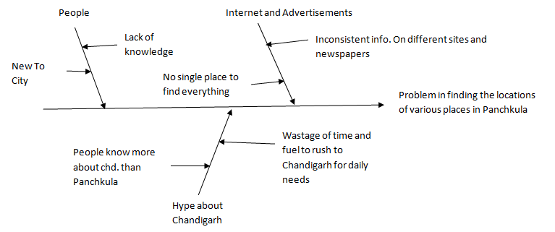

**DESIGN**

1. FUNCTIONALITIES

There are 2 functional components :

1. User End
2. Administrator End

**User End:** The user who vists the application can perform one of these activities :

1. View details about any category of its sub-categories.
2. Make an account if not already registered to visit Blog section where he can perform 3 tasks namely :-

* View existing questions on any category.
* Add answer to a question.
* Ask a new question.

**Administration End:** The administration module takes care of the admin work which includes maintaining the database and blogs, inserting the new items and updating the tables on time.

* Enter new details in any category.
* Enter new category

DATA FLOW DIAGRAM

DFD LEVEL 0

GUI

Authenticates admin to make changes

Logs in and makes a database

entry

Request for viewing details or entry in the blog section

Display Details

USER

ADMIN

DFD LEVEL 1 ( for Blog and details Module)

Update database

Request for details

Fetch details

Display

Request for viewing details

DATABASE

BLOG SECTION

USER

DETAILS MODULE

Login if registered

And view the blog

USE CASE DIAGRAM

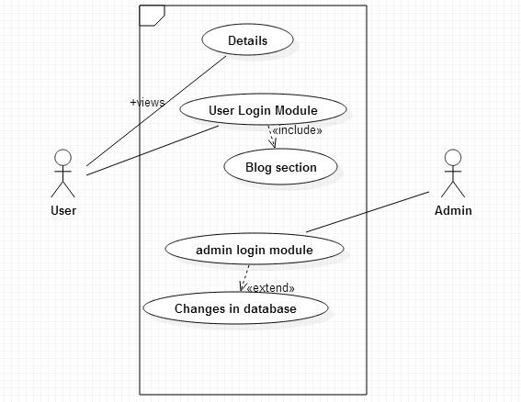

**IMPLEMENTATION**

* Main Database(Back End)
* Category table

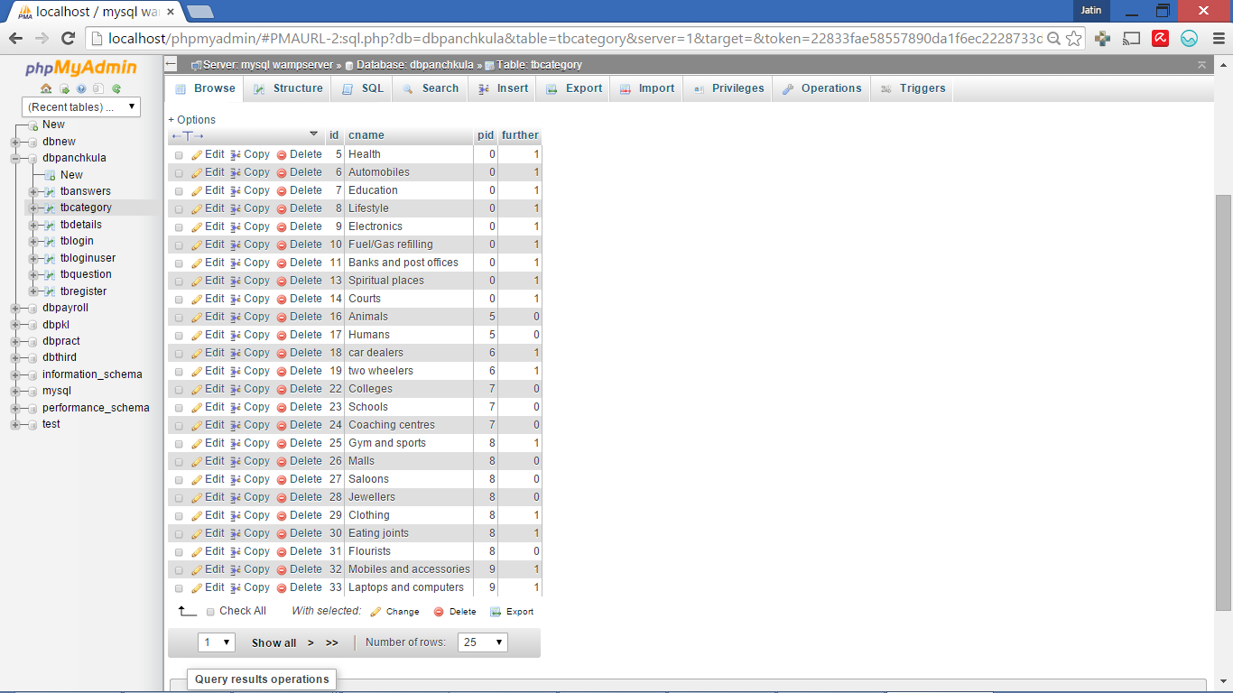

* Details Table

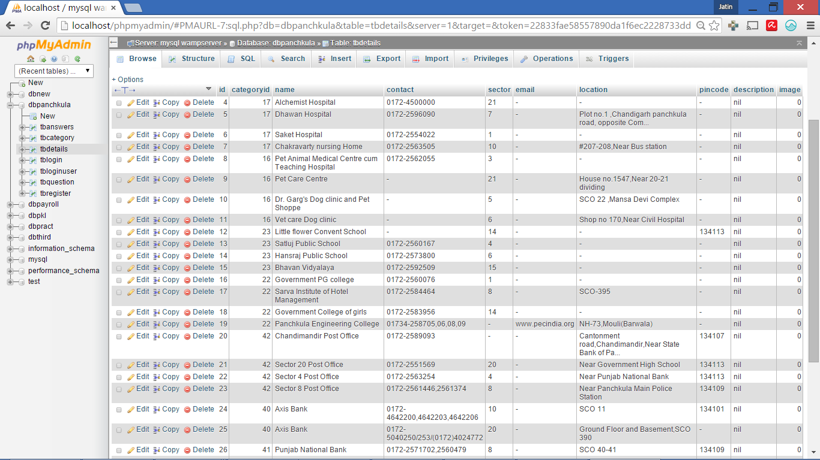

* **USER MODULE**
* View Details

All the buttons on the main frame except the Blog Section and Login as Admin are generated at the runtime i.e. added dynamically through code and not static.

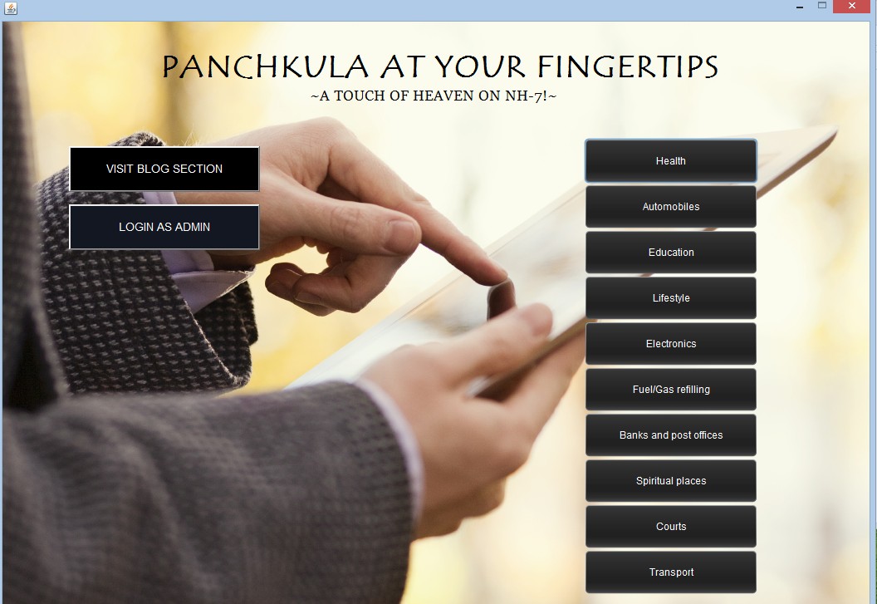

For viewing the details in any category, the user simply has to click on the button and will be directed to the sub category frame and if further categories exist, he will be directed to that frame otherwise to the Details page and view to details !

For eg :

On selecting the “lifestyle” button,the following sub-categories got displayed.If any of the categories has any further categories,then a frame similar to this one gets opened,listing the further categories depending on the id that is fetched from the previous frame.

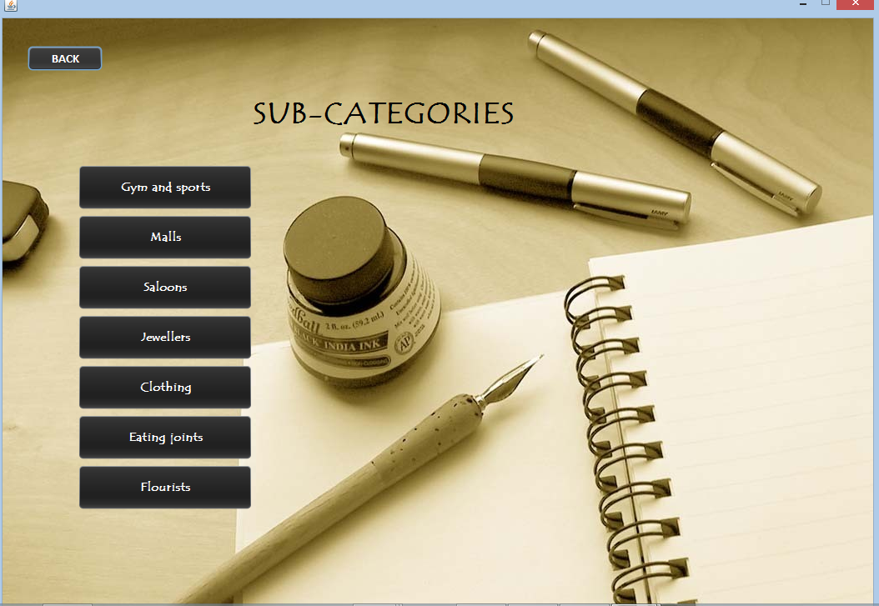

On selecting the final sub-category,the details of the ‘best’ locations listed under the category are fetched from the database and are displayed.

The table is generated in HTML where the details are automatically fetched from the database depending on the category id of the final selected categories.

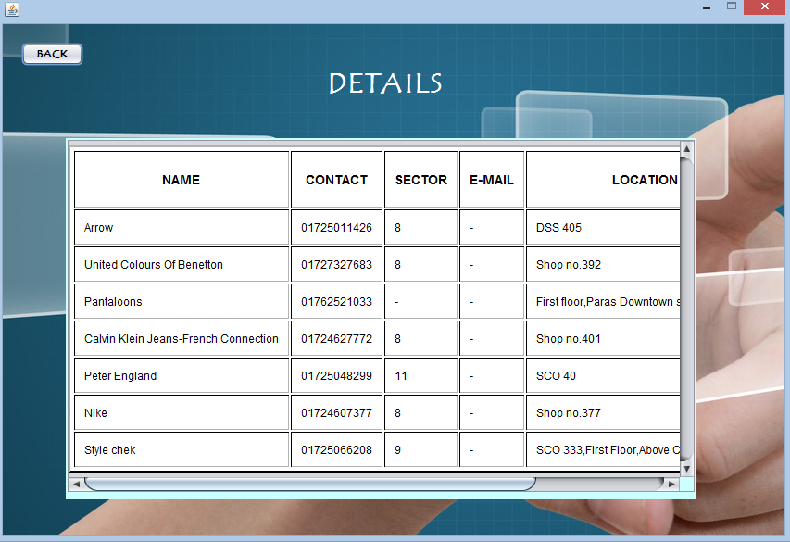

* **BLOG SECTION**

A user can only enter the blog section if he is registered, If not, a Dialog box pops up !

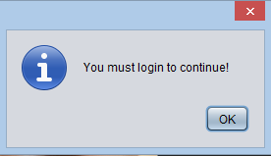

Clicking on ok directs user to the registration page :

After registration, now the user can login here, if he forgets password I have provided an option for the security ques and answer too :-

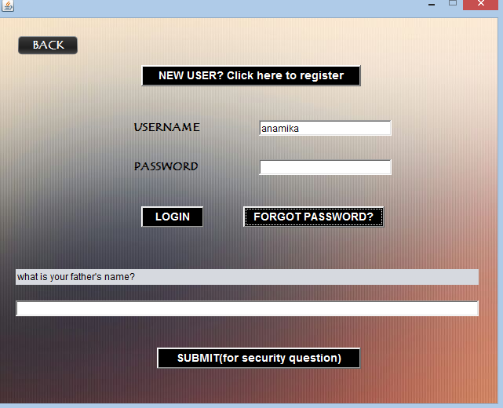

After the login is complete, he is directed to the welcome page of blog where all the categories are displayed to be clicked :

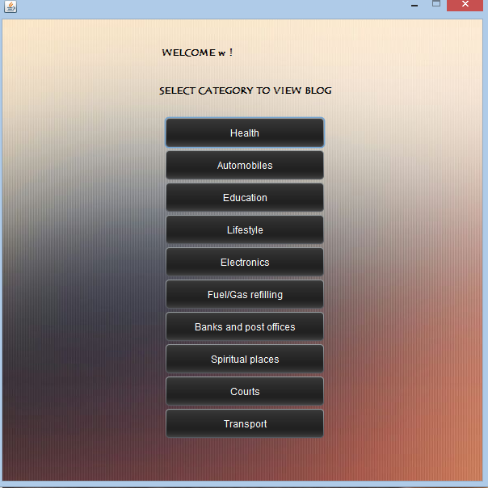

For eg: if the user clicks on the Health, he will directed to the blog section of Health !

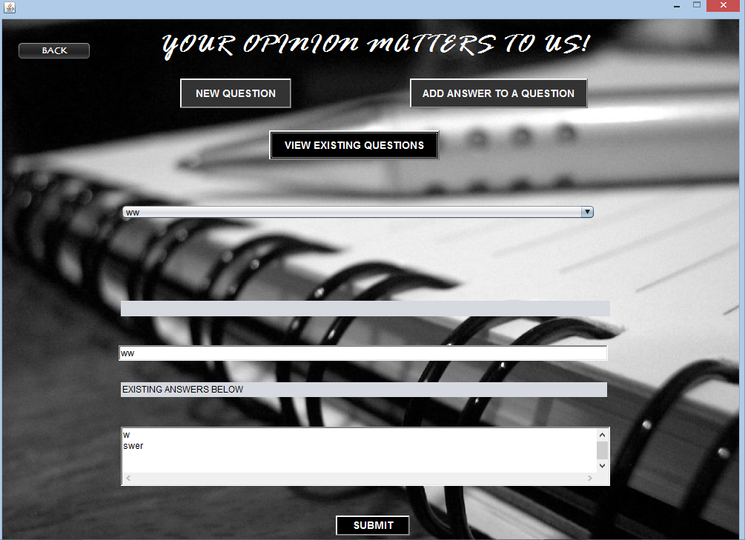

**OPTIMISATION**

No separate frames are made for each category, depending on the id of the button selected , different buttons get displayed on the same three frames. This reduced our code to a great extent.

There is no wastage of space in the final details frame as the details get displayed only in the space provided, extra details can be viewed with the help of a scroll bar.

Combo-boxes and Information message alerts made it easier for the user to select various options and know when they are making any wrong input.

**EXPERIMENTATION**

We provided the project to our friends and family in the form of a desktop application.

All of them found the project to be satisfactory,They found the blog section to be very useful for discussion on various topics and knowledge improvement.They said that it was good that no person except the admin who has a proper username and password can make any alterations in the project. This feature makes the system really secure.

We,ourselves checked the registration forms and login forms for exception handling. Exceptions would be generated if the user chooses a username that already exists,if he leaves any mandatory field empty,if the password length is less than 6 characters.

In the blog section,if he user’s answer is longer than 60 characters, it cannot be submitted. Similarly, no submission can be made in the view existing answers category.

Temporarily the project was used as a desktop application, later on, it will be converted to an android app and a website.

**EVALUATION**

The project was therefore a small scale implementation which can be used to get information of the new locations.It was found out to be satisfactory in providing information to the users who are looking forward to use it as an app.

**LIMITATIONS**

1. Database has to be updated from time to time as new restaurants, new showrooms etc. Get opened every day in the city.

2. The data in the project has been obtained from different sources which might be inconsistent.

3. We do not guarantee any place to be best,the locations stated were indicated by our reasearch based on various information portals.

4. Currently,the use of the project is cumbersome due to the hassles of installing wamp and jdk first.

**CONCLUSIONS AND FUTURE WORK**

It was realised that netbeans’ method of drag and drop provides an elegant and hassle-free way to design simple forms. Netbeans also provides with an easy method to report errors and correct them. With the help of database queries and linking the database with java, data can be easily stored and retrieved at any time.

The project gave us an opportunity to discover our beautiful city.This was just a quick and dirty implementation.We aim to improve the design and coding in the android version of this application.We also plan to extend the database to include many other categories according to the demands of the user.We plan to add maps of various destinations as another feature in the upcoming versions of our application.We might add the option of ‘How to reach’ in our app.Some other features would also be incorporated in the coming future as they could not be added as of now due to shortage of time.

We also plan to learn advanced java to convert this into a website for those who do not have smartphones but want to know about Panchkula right from their desktops.

BIBLIOGRAPHY

1. Google maps and search based on keywords
2. Zomato.com(for eating hub locations)
3. Yellowpages.sulekha.com(for other locations in Panchkula)
4. Analysis of advertisements given in Times of India and some websites